5: Online Flight Reservation System
Aim: To design and develop an online flight reservation system that allows users to search flights, book tickets, make payments, view booking status, cancel tickets, and print e-tickets.
Algorithm:
- Start the application.
- Register and log in as a user.
- Search for flights by destination, date, and class.
- Display available flights, fares, and seat availability.
- Select a flight and enter passenger details.
- Choose seats and proceed with payment.
- Confirm the booking and generate the e-ticket.
- Allow users to view, print, or cancel tickets.
- Allow the administrator to manage flights, schedules, and booking reports.
- Stop.

Code :
```html
<!DOCTYPE html>
<html lang="en">
<head>
<meta charset="UTF-8">
<meta name="viewport" content="width=device-width, initial-scale=1.0">
<title>SkyBook Flight Reservation</title>

<style>
* {
box-sizing: border-box;
}
body {
margin: 0;
font-family: Arial, sans-serif;
background: #f1f5f9;
color: #1e293b;
}
header {
background: #10294c;
color: white;
padding: 18px 5%;
display: flex;
justify-content: space-between;
align-items: center;
flex-wrap: wrap;
gap: 12px;
}
header h2 {
margin: 0;
}
nav {
display: flex;
gap: 8px;
flex-wrap: wrap;
}
main {
max-width: 1050px;
margin: 25px auto;
padding: 0 15px;
}
.hero {
background: linear-gradient(120deg, #10294c, #1672e8);
color: white;
padding: 25px;
border-radius: 15px;
margin-bottom: 20px;
}
.panel {
background: white;
padding: 22px;
margin-bottom: 20px;
border-radius: 12px;
box-shadow: 0 3px 12px #0000000c;
}
.grid {
display: grid;
grid-template-columns: repeat(auto-fit, minmax(190px, 1fr));
gap: 14px;
}
.field {
display: flex;
flex-direction: column;
gap: 7px;
}
label {
font-weight: bold;
font-size: 14px;
}
input, select, textarea {
width: 100%;
padding: 11px;
border: 1px solid #cbd5e1;
border-radius: 7px;
font-size: 15px;
}
button {
padding: 10px 14px;
border: none;
border-radius: 7px;
background: #1769e0;
color: white;
cursor: pointer;
font-weight: bold;
}
button:hover {
opacity: 0.88;
}
.secondary {
background: #e2e8f0;
color: #1e293b;
}
.danger {
background: #dc2626;
}
.hidden {
display: none !important;
}
.actions {
display: flex;
gap: 9px;
flex-wrap: wrap;
margin-top: 15px;
}
.flight {
border: 1px solid #dbe3ed;
padding: 15px;
margin-top: 12px;
border-radius: 10px;
display: flex;
justify-content: space-between;
align-items: center;
gap: 12px;
flex-wrap: wrap;
}
.price {
color: #1769e0;
font-size: 20px;
font-weight: bold;
}
.seats {
display: grid;
grid-template-columns: repeat(4, 55px);
gap: 9px;
margin: 15px 0;
}
.seat {
background: #dbeafe;
color: #1d4ed8;
}
.seat.selected {
background: #1769e0;
color: white;
}
.seat.taken {
background: #cbd5e1;
color: #64748b;
cursor: not-allowed;
}
.ticket {
border: 2px dashed #94a3b8;
border-radius: 12px;
padding: 20px;
}
.status {
color: #15803d;
font-weight: bold;
}
.cancelled {
color: #dc2626;
}
table {
width: 100%;
border-collapse: collapse;
min-width: 600px;
}
th, td {
padding: 10px;
border-bottom: 1px solid #ddd;
text-align: left;
}
th {
background: #eaf1fa;
}
.table-wrap {
overflow-x: auto;
}
.note {
background: #fff7d6;
padding: 12px;
border-radius: 8px;
font-size: 13px;
}
footer {
text-align: center;
padding: 20px;
color: #64748b;
}
@media print {
header, .hero, footer, .no-print {
display: none !important;
}
body {
background: white;
}
main {
margin: 0;
}
}
</style>
</head>

<body>

<header>
<h2>✈ SkyBook</h2>

<nav id="navigation" class="hidden">
<button onclick="showPage('searchPage')">Search Flights</button>
<button onclick="showPage('ticketsPage')">My Tickets</button>
<button onclick="showPage('feedbackPage')">Feedback</button>
<button id="adminButton" class="hidden"
onclick="showPage('adminPage')">Admin</button>
<button class="secondary" onclick="logout()">Logout</button>
</nav>
</header>

<main>

<div class="hero">
<h1>Flight Reservation System</h1>
<p>Search flights, select seats and manage your tickets online.</p>
</div>

<!-- LOGIN AND REGISTRATION -->
<section id="authPage" class="panel">
<h2 id="authHeading">Customer Login</h2>

<div id="loginForm">
<div class="grid">
<div class="field">
<label>Email</label>
<input id="loginEmail" type="email"
placeholder="Enter email">
</div>
<div class="field">
<label>Password</label>
<input id="loginPassword" type="password"
placeholder="Enter password">
</div>
</div>

<div class="actions">
<button onclick="login()">Login</button>
<button class="secondary" onclick="toggleAuth('register')">
Register
</button>
<button class="secondary" onclick="toggleAuth('forgot')">
Forgot Password
</button>
</div>

<p class="note">
Demo admin login: admin@skybook.com<br>
Password: admin123
</p>
</div>

<div id="registerForm" class="hidden">
<div class="grid">
<div class="field">
<label>Full Name</label>
<input id="regName" placeholder="Enter name">
</div>
<div class="field">
<label>Email</label>
<input id="regEmail" type="email"
placeholder="Enter email">
</div>
<div class="field">
<label>Password</label>
<input id="regPassword" type="password"
placeholder="At least 4 characters">
</div>
</div>
<div class="actions">
<button onclick="register()">Create Account</button>
<button class="secondary" onclick="toggleAuth('login')">
Back to Login
</button>
</div>
</div>

<div id="forgotForm" class="hidden">
<div class="field">
<label>Registered Email</label>
<input id="forgotEmail" type="email">
</div>
<div class="field" style="margin-top:10px">
<label>New Password</label>
<input id="forgotPassword" type="password">
</div>
<div class="actions">
<button onclick="resetPassword()">Reset Password</button>
<button class="secondary" onclick="toggleAuth('login')">
Back to Login
</button>
</div>
</div>
</section>

<!-- SEARCH FLIGHTS -->
<section id="searchPage" class="panel hidden">
<h2>Search Flights</h2>

<div class="grid">
<div class="field">
<label>From</label>
<select id="from">
<option>Hyderabad</option>
<option>Chennai</option>
<option>Bengaluru</option>
<option>Mumbai</option>
<option>Delhi</option>
<option>Kolkata</option>
</select>
</div>

<div class="field">
<label>Destination</label>
<select id="to">
<option>Delhi</option>
<option>Hyderabad</option>
<option>Chennai</option>
<option>Bengaluru</option>
<option>Mumbai</option>
<option>Kolkata</option>
</select>
</div>

<div class="field">
<label>Travel Date</label>
<input id="travelDate" type="date">
</div>

<div class="field">
<label>Travel Class</label>
<select id="travelClass">
<option>Economy</option>
<option>Business</option>
<option>First</option>
</select>
</div>

<div class="field">
<label>Passengers</label>
<select id="passengers">
<option value="1">1 Passenger</option>
<option value="2">2 Passengers</option>
<option value="3">3 Passengers</option>
<option value="4">4 Passengers</option>
<option value="5">5 Passengers</option>
<option value="6">6 Passengers</option>
</select>
</div>
</div>

<div class="actions">
<button onclick="searchFlights()">Search Flights</button>
</div>

<div id="flightResults"></div>

<p class="note">
These are sample flights and fares for the lab demonstration.
</p>
</section>

<!-- BOOK TICKET -->
<section id="bookingPage" class="panel hidden">
<h2>Book Ticket</h2>
<div id="selectedFlightInfo"></div>

<h3>Select Seats</h3>
<p>Blue = available, dark blue = selected, grey = booked.</p>
<div id="seatGrid" class="seats"></div>
<p id="seatInfo"></p>

<h3>Passenger Details</h3>
<div id="passengerFields" class="grid"></div>

<h3>Payment</h3>
<div class="grid">
<div class="field">
<label>Payment Method</label>
<select id="paymentMethod">
<option>Demo Card</option>
<option>UPI Demo</option>
<option>Net Banking Demo</option>
</select>
</div>
<div class="field">
<label>Demo Payment Reference</label>
<input id="paymentReference"
placeholder="Enter any demo reference">
</div>
</div>

<p class="note">
This is a simulated payment. No real money is charged.
Never enter real card details in this demo.
</p>

<div class="actions">
<button onclick="confirmBooking()">Pay & Confirm</button>
<button class="secondary" onclick="showPage('searchPage')">
Back
</button>
</div>
<p id="bookingError" style="color:red"></p>
</section>

<!-- MY TICKETS -->
<section id="ticketsPage" class="panel hidden">
<h2>My Tickets / Booking History</h2>
<div id="ticketList"></div>
</section>

<!-- PRINTABLE TICKET -->
<section id="ticketPage" class="panel hidden">
<h2>Flight E-Ticket</h2>
<div id="ticketOutput"></div>
<div class="actions no-print">
<button onclick="window.print()">Print Ticket</button>
<button class="secondary" onclick="showPage('ticketsPage')">
My Tickets
</button>
</div>
</section>

<!-- FEEDBACK -->
<section id="feedbackPage" class="panel hidden">
<h2>Customer Feedback</h2>

<div class="field">
<label>Rating</label>
<select id="rating">
<option>5 - Excellent</option>
<option>4 - Very Good</option>
<option>3 - Good</option>
<option>2 - Fair</option>
<option>1 - Poor</option>
</select>
</div>

<div class="field" style="margin-top:12px">
<label>Comments</label>
<textarea id="feedbackText"
placeholder="Enter your feedback"></textarea>
</div>

<div class="actions">
<button onclick="submitFeedback()">Submit Feedback</button>
</div>
<p id="feedbackMessage"></p>
</section>

<!-- ADMIN PANEL -->
<section id="adminPage" class="panel hidden">
<h2>Admin Dashboard and Report</h2>
<div id="adminStats" class="grid"></div>

<h3>All Bookings</h3>
<div class="table-wrap" id="adminReport"></div>

<h3>Add Flight Schedule</h3>
<div class="grid">
<div class="field">
<label>Flight Number</label>
<input id="newFlightNo" placeholder="SB 707">
</div>
<div class="field">
<label>From</label>
<input id="newFrom" placeholder="Hyderabad">
</div>
<div class="field">
<label>To</label>
<input id="newTo" placeholder="Delhi">
</div>
<div class="field">
<label>Departure</label>
<input id="newDeparture" placeholder="10:30">
</div>
<div class="field">
<label>Arrival</label>
<input id="newArrival" placeholder="12:45">
</div>
<div class="field">
<label>Base Fare (₹)</label>
<input id="newFare" type="number" min="1">
</div>
<div class="field">
<label>Seat Count</label>
<input id="newSeats" type="number" min="1" value="24">
</div>
</div>

<div class="actions">
<button onclick="addFlight()">Add Flight</button>
<button class="secondary" onclick="exportReport()">
Export CSV Report
</button>
</div>

<h3>Customer Feedback Report</h3>
<div id="feedbackReport"></div>
</section>

</main>

<footer>SkyBook Flight Reservation System | Internet Programming Lab</footer>

<script>
// DATA STORAGE
const USERS = "skybook_users";
const FLIGHTS = "skybook_flights";
const BOOKINGS = "skybook_bookings";
const FEEDBACK = "skybook_feedback";

function getData(key) {
return JSON.parse(localStorage.getItem(key) || "[]");
}
function saveData(key, data) {
localStorage.setItem(key, JSON.stringify(data));
}

const defaultFlights = [
{id:"F101", no:"SB 101", from:"Hyderabad", to:"Delhi",
depart:"06:30", arrive:"08:50", fare:4200, seats:24},
{id:"F102", no:"SB 102", from:"Hyderabad", to:"Mumbai",
depart:"09:15", arrive:"11:00", fare:3600, seats:24},
{id:"F103", no:"SB 103", from:"Chennai", to:"Bengaluru",
depart:"12:20", arrive:"13:20", fare:2200, seats:24},
{id:"F104", no:"SB 104", from:"Bengaluru", to:"Delhi",
depart:"15:10", arrive:"18:00", fare:5100, seats:24},
{id:"F105", no:"SB 105", from:"Mumbai", to:"Kolkata",
depart:"18:00", arrive:"20:45", fare:4700, seats:24},
{id:"F106", no:"SB 106", from:"Delhi", to:"Chennai",
depart:"20:10", arrive:"23:00", fare:4900, seats:24}
];

if (!localStorage.getItem(FLIGHTS)) {
saveData(FLIGHTS, defaultFlights);
}

if (!getData(USERS).some(u => u.email === "admin@skybook.com")) {
saveData(USERS, [
...getData(USERS),
{
name:"Administrator",
email:"admin@skybook.com",
password:"admin123",
role:"admin"
}
]);
}

let currentUser = null;
let selectedFlight = null;
let selectedSeats = [];

function safe(value) {
return String(value ?? "").replace(/[&<>"']/g, c => ({
"&":"&amp;", "<":"&lt;", ">":"&gt;",
'"':"&quot;", "'":"&#39;"
}[c]));
}

function toggleAuth(type) {
["loginForm","registerForm","forgotForm"].forEach(id =>
document.getElementById(id).classList.add("hidden")
);
document.getElementById(type + "Form").classList.remove("hidden");

document.getElementById("authHeading").textContent =
type === "login" ? "Customer Login" :
type === "register" ? "Create Account" : "Forgot Password";
}

function register() {
const name = document.getElementById("regName").value.trim();
const email = document.getElementById("regEmail").value.trim().toLowerCase();
const password = document.getElementById("regPassword").value;

if (!name || !email || password.length < 4) {
alert("Enter your name, email and a password of at least 4 characters.");
return;
}

const users = getData(USERS);

if (users.some(u => u.email === email)) {
alert("Email already registered.");
return;
}

users.push({name, email, password, role:"customer"});
saveData(USERS, users);

alert("Registration successful. Please log in.");
document.getElementById("loginEmail").value = email;
toggleAuth("login");
}

function login() {
const email = document.getElementById("loginEmail").value.trim().toLowerCase();
const password = document.getElementById("loginPassword").value;

const user = getData(USERS).find(
u => u.email === email && u.password === password
);

if (!user) {
alert("Invalid email or password.");
return;
}

currentUser = user;
document.getElementById("authPage").classList.add("hidden");
document.getElementById("navigation").classList.remove("hidden");
document.getElementById("adminButton").classList.toggle(
"hidden", user.role !== "admin"
);

const tomorrow = new Date();
tomorrow.setDate(tomorrow.getDate() + 1);
document.getElementById("travelDate").min =
new Date().toISOString().slice(0,10);
document.getElementById("travelDate").value =
tomorrow.toISOString().slice(0,10);

showPage("searchPage");
}

function resetPassword() {
const email = document.getElementById("forgotEmail").value.trim().toLowerCase();
const password = document.getElementById("forgotPassword").value;
const users = getData(USERS);
const user = users.find(u => u.email === email && u.role === "customer");

if (!user || password.length < 4) {
alert("Enter a registered customer email and a password of at least 4 characters.");
return;
}

user.password = password;
saveData(USERS, users);
alert("Password reset. Please log in.");
toggleAuth("login");
}

function logout() {
currentUser = null;
document.getElementById("navigation").classList.add("hidden");
document.getElementById("authPage").classList.remove("hidden");

["searchPage","bookingPage","ticketsPage","ticketPage",
"feedbackPage","adminPage"].forEach(id =>
document.getElementById(id).classList.add("hidden")
);
toggleAuth("login");
}

function showPage(id) {
if (!currentUser) return;
if (id === "adminPage" && currentUser.role !== "admin") {
alert("Admin access only.");
return;
}

["searchPage","bookingPage","ticketsPage","ticketPage",
"feedbackPage","adminPage"].forEach(page =>
document.getElementById(page).classList.add("hidden")
);

document.getElementById(id).classList.remove("hidden");

if (id === "ticketsPage") renderTickets();
if (id === "adminPage") renderAdmin();
}

// FLIGHT SEARCH
function getBookings() {
return getData(BOOKINGS);
}

function getBookedSeats(flightId, date) {
return getBookings()
.filter(b => b.flightId === flightId &&
b.date === date && b.status === "Confirmed")
.flatMap(b => b.seats);
}

function searchFlights() {
const from = document.getElementById("from").value;
const to = document.getElementById("to").value;
const date = document.getElementById("travelDate").value;
const travelClass = document.getElementById("travelClass").value;

if (from === to) {
alert("Origin and destination must be different.");
return;
}
if (!date || date < new Date().toISOString().slice(0,10)) {
alert("Choose a valid travel date.");
return;
}

const flights = getData(FLIGHTS).filter(f =>
f.from.toLowerCase() === from.toLowerCase() &&
f.to.toLowerCase() === to.toLowerCase()
);

const results = document.getElementById("flightResults");

if (!flights.length) {
results.innerHTML = "<p>No sample flights found. Try Hyderabad to Delhi or another listed route.</p>";
return;
}

results.innerHTML = flights.map(f => {
const available = f.seats - getBookedSeats(f.id, date).length;
const fare = Math.round(
f.fare * (travelClass === "Business" ? 2.1 :
travelClass === "First" ? 3.2 : 1)
);

return `
<div class="flight">
<div>
<b>${safe(f.no)}</b>
<p>${safe(f.from)} → ${safe(f.to)}</p>
<small>${safe(f.depart)} - ${safe(f.arrive)}</small>
</div>
<div>
<p>${safe(date)}</p>
<small>${available} seats available</small>
</div>
<div>
<div class="price">₹${fare.toLocaleString("en-IN")}</div>
<small>${safe(travelClass)}</small>
</div>
<button ${available <= 0 ? "disabled" : ""}
onclick="startBooking('${safe(f.id)}',${fare},'${safe(travelClass)}','${safe(date)}')">
Select
</button>
</div>`;
}).join("");
}

// SEAT SELECTION AND BOOKING
function startBooking(id, fare, travelClass, date) {
const flight = getData(FLIGHTS).find(f => f.id === id);
selectedFlight = {...flight, fare, travelClass, date};
selectedSeats = [];

const count = Number(document.getElementById("passengers").value);

document.getElementById("passengerFields").innerHTML =
Array.from({length:count}, (_,i) => `
<div class="field">
<label>Passenger ${i+1} Name</label>
<input id="pname${i}" placeholder="Full name">
</div>
<div class="field">
<label>Passenger ${i+1} Age</label>
<input id="page${i}" type="number" min="1" max="120">
</div>
`).join("");

document.getElementById("paymentReference").value = "";
document.getElementById("bookingError").textContent = "";
renderSeats();
showPage("bookingPage");
}

function renderSeats() {
const f = selectedFlight;
const booked = getBookedSeats(f.id, f.date);
const count = Number(document.getElementById("passengers").value);

document.getElementById("selectedFlightInfo").innerHTML = `
<h3>${safe(f.no)}: ${safe(f.from)} → ${safe(f.to)}</h3>
<p>Date: ${safe(f.date)} | Class: ${safe(f.travelClass)}</p>
<p>Fare per passenger: ₹${f.fare.toLocaleString("en-IN")}</p>
<p>Total: ₹${(f.fare * count).toLocaleString("en-IN")}</p>
`;

document.getElementById("seatGrid").innerHTML =
Array.from({length:f.seats}, (_,i) => {
const seat = String.fromCharCode(65 + Math.floor(i/6)) + (i%6+1);
const taken = booked.includes(seat);
const selected = selectedSeats.includes(seat);

return `<button class="seat ${taken ? "taken" : ""} ${selected ? "selected" : ""}"
${taken ? "disabled" : ""}
onclick="toggleSeat('${seat}')">${seat}</button>`;
}).join("");

document.getElementById("seatInfo").textContent =
"Selected seats: " + (selectedSeats.join(", ") || "None") +
` (${selectedSeats.length}/${count})`;
}

function toggleSeat(seat) {
const count = Number(document.getElementById("passengers").value);

if (selectedSeats.includes(seat)) {
selectedSeats = selectedSeats.filter(s => s !== seat);
} else if (selectedSeats.length < count) {
selectedSeats.push(seat);
} else {
alert("You have selected enough seats.");
return;
}
renderSeats();
}

function confirmBooking() {
const count = Number(document.getElementById("passengers").value);
const passengers = [];

for (let i = 0; i < count; i++) {
const name = document.getElementById("pname" + i).value.trim();
const age = Number(document.getElementById("page" + i).value);

if (!name || age < 1 || age > 120) {
document.getElementById("bookingError").textContent =
"Enter a valid name and age for every passenger.";
return;
}
passengers.push({name, age});
}

if (selectedSeats.length !== count) {
document.getElementById("bookingError").textContent =
`Please select exactly ${count} seat(s).`;
return;
}

if (!document.getElementById("paymentReference").value.trim()) {
document.getElementById("bookingError").textContent =
"Enter a demo payment reference.";
return;
}

const bookings = getBookings();
const taken = getBookedSeats(selectedFlight.id, selectedFlight.date);

if (selectedSeats.some(s => taken.includes(s))) {
alert("A selected seat is no longer available. Choose another seat.");
renderSeats();
return;
}

const booking = {
id: "SB" + Date.now().toString().slice(-8),
user: currentUser.email,
customerName: currentUser.name,
flightId: selectedFlight.id,
flightNo: selectedFlight.no,
from: selectedFlight.from,
to: selectedFlight.to,
date: selectedFlight.date,
depart: selectedFlight.depart,
arrive: selectedFlight.arrive,
travelClass: selectedFlight.travelClass,
seats: [...selectedSeats],
passengers,
total: selectedFlight.fare * count,
paymentMethod: document.getElementById("paymentMethod").value,
status: "Confirmed",
created: new Date().toLocaleString()
};

bookings.push(booking);
saveData(BOOKINGS, bookings);
renderTicket(booking);
showPage("ticketPage");
}

// TICKET DISPLAY AND PRINT
function renderTicket(b) {
document.getElementById("ticketOutput").innerHTML = `
<div class="ticket">
<h2>✈ SkyBook E-Ticket</h2>
<p><b>Booking ID:</b> ${safe(b.id)}</p>
<p><b>Status:</b>
<span class="${b.status === "Cancelled" ? "cancelled" : "status"}">
${safe(b.status)}
</span>
</p>
<hr>
<div class="grid">
<div><small>From</small><h2>${safe(b.from)}</h2><b>${safe(b.depart)}</b></div>
<div><small>To</small><h2>${safe(b.to)}</h2><b>${safe(b.arrive)}</b></div>
<div><small>Travel Date</small><h3>${safe(b.date)}</h3></div>
<div><small>Flight / Class</small><h3>${safe(b.flightNo)} / ${safe(b.travelClass)}</h3></div>
</div>
<hr>
<h3>Passengers</h3>
<ul>${b.passengers.map(p =>
`<li>${safe(p.name)} - Age ${safe(p.age)}</li>`
).join("")}</ul>
<p><b>Seats:</b> ${b.seats.map(safe).join(", ")}</p>
<p><b>Payment method:</b> ${safe(b.paymentMethod)} (demo)</p>
<h2>Total: ₹${Number(b.total).toLocaleString("en-IN")}</h2>
<p><small>Booking time: ${safe(b.created)}</small></p>
</div>`;
}

// BOOKING HISTORY AND CANCELLATION
function renderTickets() {
const list = getBookings()
.filter(b => b.user === currentUser.email)
.reverse();

document.getElementById("ticketList").innerHTML = list.length ?
list.map(b => `
<div class="panel">
<h3>${safe(b.flightNo)}: ${safe(b.from)} → ${safe(b.to)}</h3>
<p>Date: ${safe(b.date)} | Booking ID: ${safe(b.id)}</p>
<p>Seats: ${b.seats.map(safe).join(", ")}</p>
<p>Total: ₹${Number(b.total).toLocaleString("en-IN")}</p>
<p class="${b.status === "Cancelled" ? "cancelled" : "status"}">
${safe(b.status)}
</p>
<div class="actions">
<button onclick="viewTicket('${safe(b.id)}')">
View / Print Ticket
</button>
${b.status === "Confirmed" &&
b.date >= new Date().toISOString().slice(0,10) ?
`<button class="danger"
onclick="cancelTicket('${safe(b.id)}')">
Cancel Ticket
</button>` : ""}
</div>
</div>
`).join("") : "<p>No tickets found. Search for a flight to book.</p>";
}

function viewTicket(id) {
const b = getBookings().find(
x => x.id === id && x.user === currentUser.email
);
if (b) {
renderTicket(b);
showPage("ticketPage");
}
}

function cancelTicket(id) {
if (!confirm("Cancel this ticket? This demo does not process refunds.")) return;

const bookings = getBookings();
const booking = bookings.find(
b => b.id === id && b.user === currentUser.email
);

if (booking) {
booking.status = "Cancelled";
saveData(BOOKINGS, bookings);
renderTickets();
}
}

// CUSTOMER FEEDBACK
function submitFeedback() {
const message = document.getElementById("feedbackText").value.trim();

if (!message) {
alert("Please enter your feedback.");
return;
}

const feedback = getData(FEEDBACK);
feedback.push({
name: currentUser.name,
email: currentUser.email,
rating: document.getElementById("rating").value,
message,
date: new Date().toLocaleString()
});

saveData(FEEDBACK, feedback);
document.getElementById("feedbackText").value = "";
document.getElementById("feedbackMessage").textContent =
"Thank you! Feedback submitted successfully.";
}

// ADMIN REPORT
function renderAdmin() {
const bookings = getBookings();
const confirmed = bookings.filter(b => b.status === "Confirmed");
const users = getData(USERS).filter(u => u.role === "customer");

document.getElementById("adminStats").innerHTML = `
<div class="panel">Total bookings<h2>${bookings.length}</h2></div>
<div class="panel">Confirmed<h2>${confirmed.length}</h2></div>
<div class="panel">Cancelled<h2>${bookings.length-confirmed.length}</h2></div>
<div class="panel">Customers<h2>${users.length}</h2></div>
<div class="panel">Confirmed demo sales<h2>₹${confirmed.reduce((s,b)=>s+b.total,0).toLocaleString("en-IN")}</h2></div>
`;

document.getElementById("adminReport").innerHTML = bookings.length ?
`<table>
<tr><th>Booking ID</th><th>Customer</th><th>Route</th>
<th>Date</th><th>Seats</th><th>Fare</th><th>Status</th></tr>
${bookings.map(b => `
<tr>
<td>${safe(b.id)}</td>
<td>${safe(b.customerName)}<br>${safe(b.user)}</td>
<td>${safe(b.from)} → ${safe(b.to)}</td>
<td>${safe(b.date)}</td>
<td>${b.seats.map(safe).join(", ")}</td>
<td>₹${Number(b.total).toLocaleString("en-IN")}</td>
<td>${safe(b.status)}</td>
</tr>
`).join("")}
</table>` : "<p>No bookings yet.</p>";

const feedback = getData(FEEDBACK);
document.getElementById("feedbackReport").innerHTML = feedback.length ?
feedback.map(f => `
<div class="panel">
<b>${safe(f.name)}</b> - ${safe(f.rating)}
<p>${safe(f.message)}</p>
<small>${safe(f.date)}</small>
</div>
`).join("") : "<p>No feedback received.</p>";
}

function addFlight() {
const no = document.getElementById("newFlightNo").value.trim();
const from = document.getElementById("newFrom").value.trim();
const to = document.getElementById("newTo").value.trim();
const depart = document.getElementById("newDeparture").value.trim();
const arrive = document.getElementById("newArrival").value.trim();
const fare = Number(document.getElementById("newFare").value);
const seats = Number(document.getElementById("newSeats").value);

if (!no || !from || !to || from.toLowerCase() === to.toLowerCase() ||
!depart || !arrive || fare <= 0 || seats < 1) {
alert("Enter valid details for all flight fields.");
return;
}

const flights = getData(FLIGHTS);

if (flights.some(f => f.no.toLowerCase() === no.toLowerCase())) {
alert("Flight number already exists.");
return;
}

flights.push({
id: "F" + Date.now(),
no, from, to, depart, arrive, fare, seats
});

saveData(FLIGHTS, flights);
alert("Sample flight added successfully.");
renderAdmin();
}

function exportReport() {
const bookings = getBookings();
const rows = [
["Booking ID","Customer","Email","From","To","Date","Flight","Seats","Fare","Status"],
...bookings.map(b => [
b.id, b.customerName, b.user, b.from, b.to, b.date,
b.flightNo, b.seats.join(" "), b.total, b.status
])
];

const csv = rows.map(row =>
row.map(value => '"' + String(value).replace(/"/g,'""') + '"').join(",")
).join("\r\n");

const url = URL.createObjectURL(
new Blob([csv], {type:"text/csv;charset=utf-8;"})
);
const link = document.createElement("a");
link.href = url;
link.download = "flight_booking_report.csv";
link.click();
URL.revokeObjectURL(url);
}
</script>

</body>
</html>
```
Output :
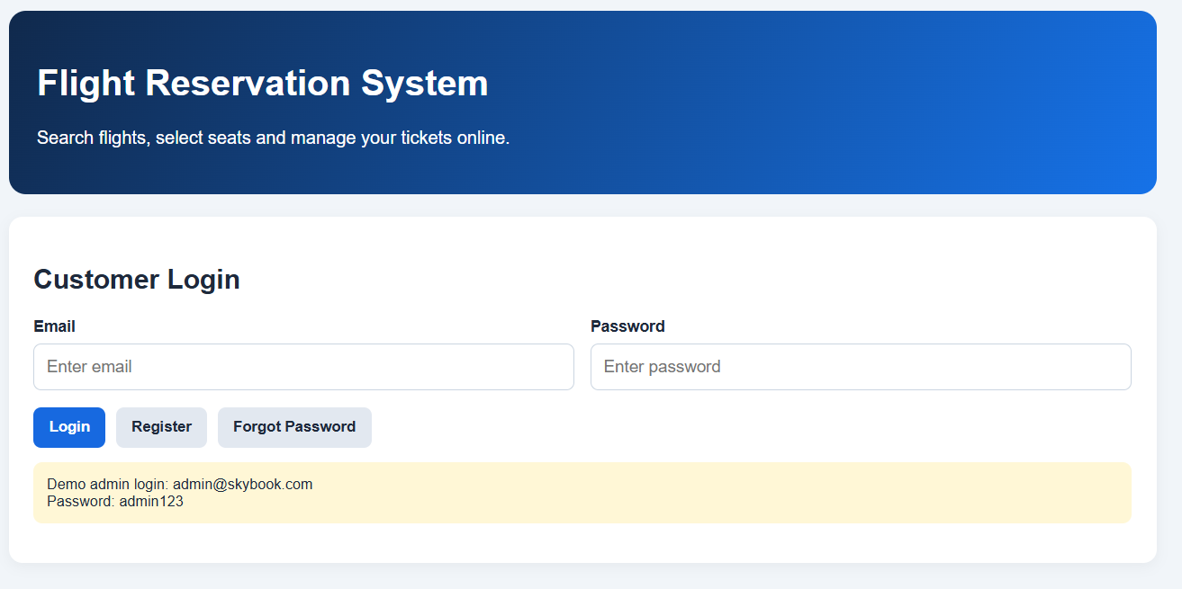
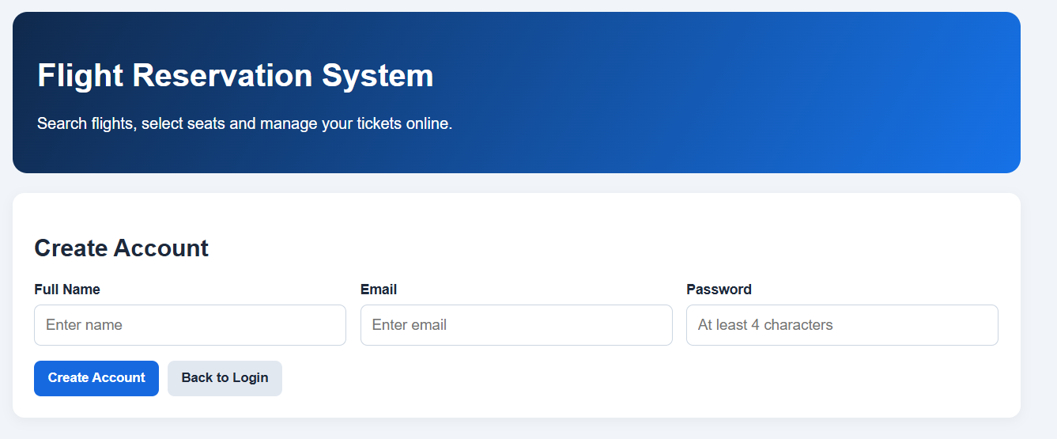
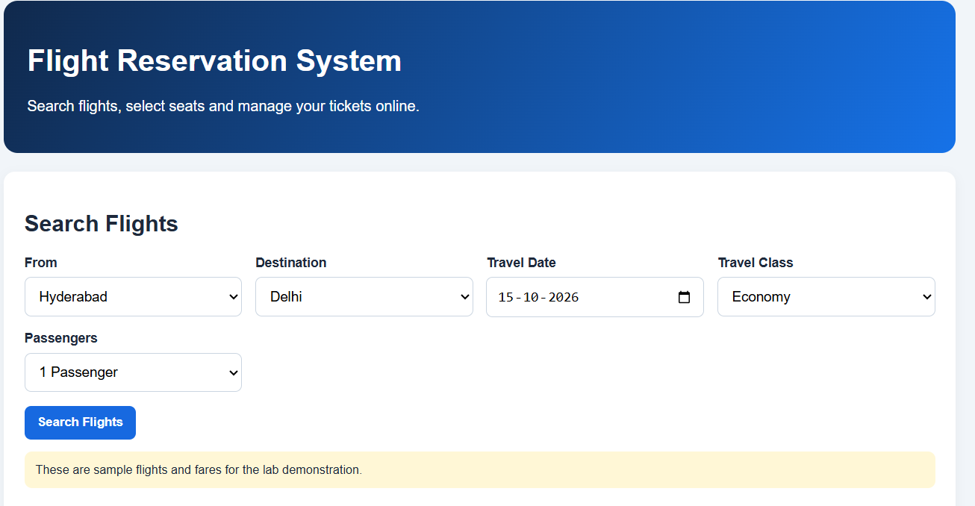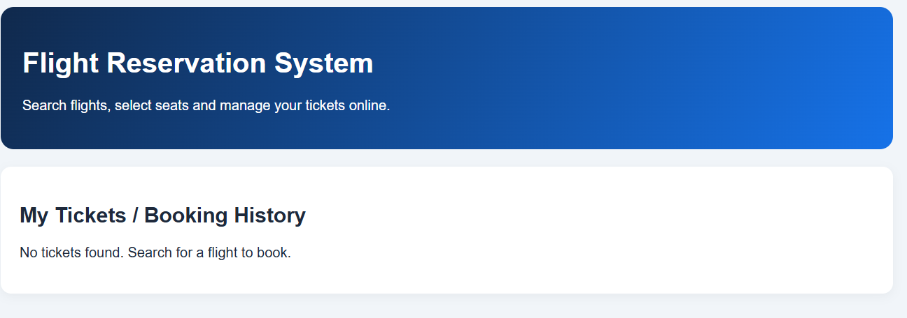
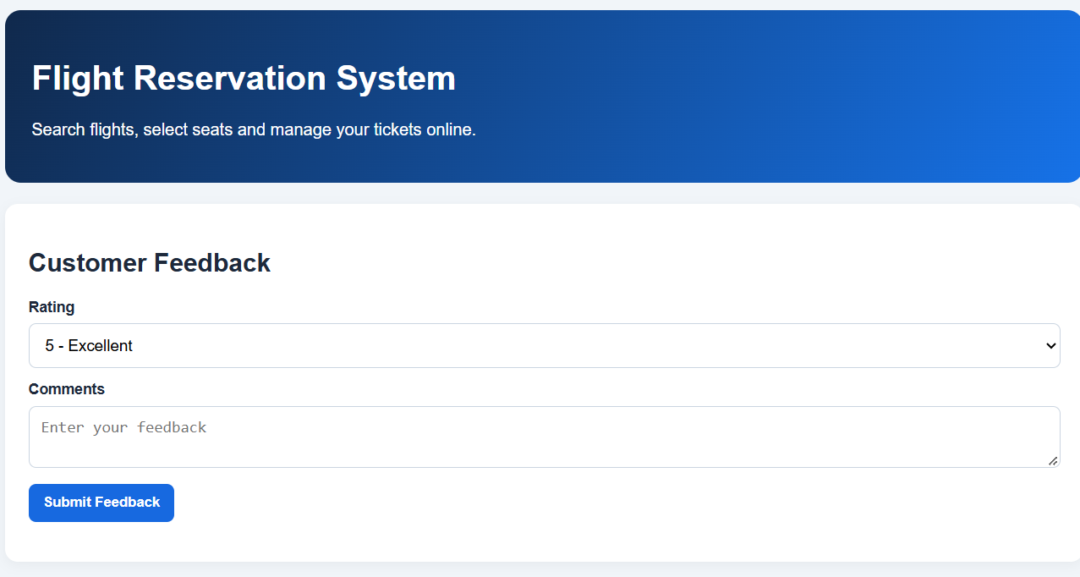
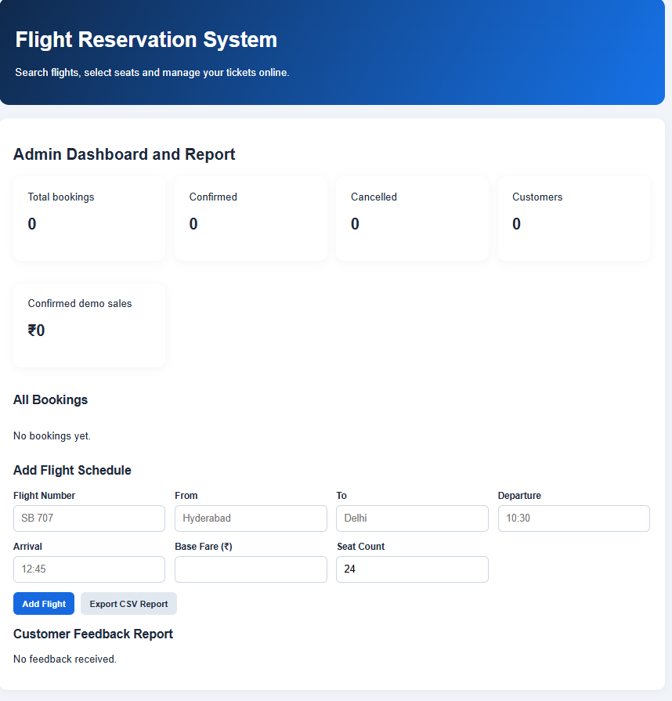
Result : Thus, the online flight reservation system was designed and developed successfully to provide flight searching, ticket booking, payment, cancellation, and ticket management facilities.

